FML UNIT 2

Bias Variance Tradeoff:
(Bias, Variance, Bias-Variance Tradeoff and Relation to Underfitting & Overfitting)
1. Bias
- Bias is the difference between the predicted values of a machine learning model and the actual correct values.
- High bias results in large errors in both training and testing datasets.
- Models with high bias are typically too simple or linear, and they fail to capture the underlying patterns in the data.
- This situation is called underfitting, where the predicted values lie roughly on a straight line and do not fit the data accurately.
- To avoid underfitting, an algorithm should ideally have low bias.
- Example hypothesis with high bias:
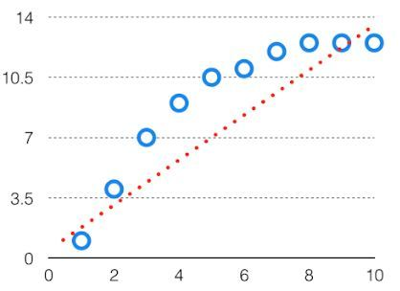
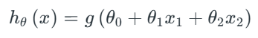
Here, the model is too simple to capture complex patterns in the data.

2. Variance
- Variance is the variability of model predictions for a given data point, which shows how spread out the predictions are.
- A model with high variance fits the training data very closely, including the noise.
- Such models perform very well on training data but have high error rates on testing data, meaning they fail to generalize.
- This situation is called overfitting, where a complex model fits the training data accurately using high-order hypotheses but does not work well on new, unseen data.
- During training, variance should be kept low to ensure better generalization.
- Example hypothesis with high variance:
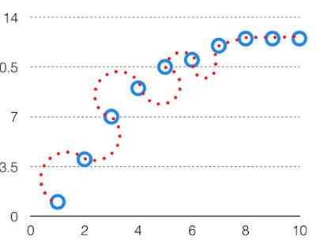
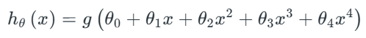
Here, the model is too complex and memorizes the training data rather than learning patterns.

3. Bias-Variance Tradeoff
- If a model is too simple (e.g., linear), it will have high bias and low variance, leading to errors in both training and testing.
- If a model is too complex (e.g., high-degree polynomial), it will have low bias and high variance, and it will not perform well on new data.
- The balance between these two extremes is called the bias-variance tradeoff, which ensures that a model is neither too simple nor too complex.
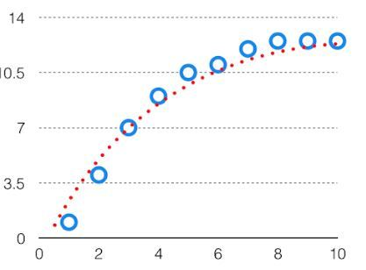
For the graph the perfect tradeoff will be like this.
- Total prediction error can be expressed as:
- Bias²: Error due to wrong or simplistic assumptions.
- Variance: Error due to sensitivity to fluctuations in training data.
- Irreducible Error: Error due to noise in the data that cannot be removed.
- The goal is to select a model with minimum total error, which is usually at an intermediate complexity point known as the optimal tradeoff point.
- At this point, the hypothesis provides the best fit, giving low error on both training and testing datasets.
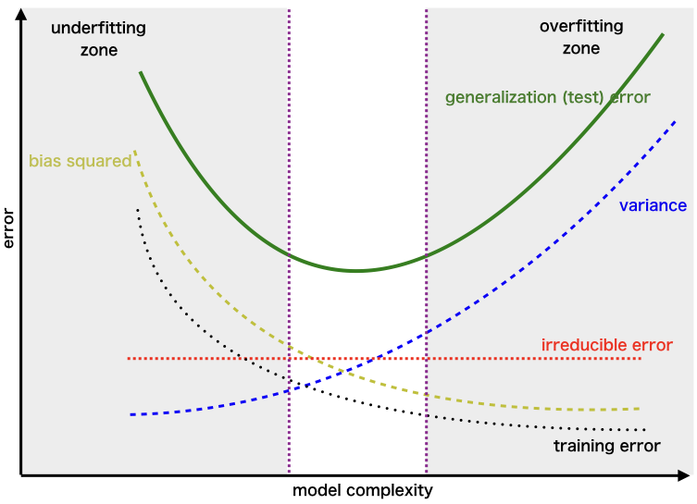

4. Relation of Underfitting and Overfitting to Bias and Variance
- Underfitting occurs when the model is too simple to capture the data patterns.
  - It is caused by high bias.
  - It is characterized by low variance because the model is not sensitive to training data.
  - Errors are high in both training and testing.
- Overfitting occurs when the model is too complex and fits training data too closely, including noise.
  - It is caused by high variance.
  - It is characterized by low bias because the model can fit training data very well.
  - Errors are low in training but high in testing because the model fails to generalize.

Difference Between Underfitting and Overfitting
Feature | Underfitting | Overfitting
Definition | Model is too simple to capture patterns in the data. | Model is too complex and fits training data too closely, including noise.
Cause | High bias; low model complexity. | High variance; high model complexity.
Training Error | High | Low
Testing Error | High | High
Model Complexity | Too simple | Too complex
Generalization | Poor; model fails to learn patterns. | Poor; model memorizes training data but fails on unseen data.
Example | Fitting a straight line to nonlinear data. | Fitting a 10th-degree polynomial to 10 points of data.
Solution | Increase model complexity; reduce bias. | Simplify model; regularization; reduce variance; get more data.

Principal Component Analysis (PCA) (also look in unit 3 for this)
1. Introduction
PCA (Principal Component Analysis) is a dimensionality reduction technique used in data analysis and machine learning. It helps you to reduce the number of features in a dataset while keeping the most important information. It changes your original features into new features these new features don’t overlap with each other and the first few keep most of the important differences found in the original data.
PCA is commonly used for data preprocessing for use with machine learning algorithms. It helps to remove redundancy, improve computational efficiency and make data easier to visualize and analyze especially when dealing with high-dimensional data.

2. How PCA Works
PCA uses linear algebra to transform data into new features called principal components. It finds these by calculating eigenvectors (directions) and eigenvalues (importance) from the covariance matrix. PCA selects the top components with the highest eigenvalues and projects the data onto them simplify the dataset.
Note: It prioritizes the directions where the data varies the most because more variation = more useful information.

Step 1: Standardize the Data
Different features may have different units and scales like salary vs. age. To compare them fairly PCA first standardizes the data by making each feature have:
- A mean of 0
- A standard deviation of 1
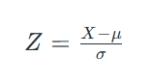
where:
- μ is the mean of independent features μ={μ₁,μ₂,⋯,μ_{m}}
- σ is the standard deviation of independent features σ={σ₁,σ₂,⋯,σ_{m}}

Standardization ensures that features with larger scales do not dominate the analysis.

Step 2: Calculate the Covariance Matrix
The covariance matrix captures the relationships between the features, indicating how they vary together. For two features x₁ and x₂, the covariance is computed as:
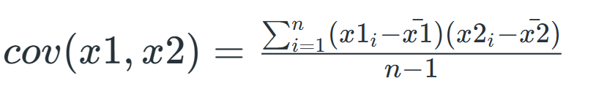
Where xˉ₁ and xˉ₂ are the mean values of features x₁ and x₂, respectively, and n is the number of data points.
Step 3: Compute Eigenvalues and Eigenvectors
Eigenvectors represent the directions of maximum variance, and eigenvalues denote their magnitude. By solving the eigenvalue equation:
A⋅X=λ⋅X
Where A is the covariance matrix, X is the eigenvector, and λ is the eigenvalue. The eigenvectors determine the new axes (principal components), and the eigenvalues indicate the amount of variance captured by each principal component.
Step 4: Select Top k Principal Components
Sort the eigenvalues in descending order and select the top k components that capture most of the variance like 95%. These top k eigenvectors form a new matrix.
Step 5: Transform the Original Data
Transform the original dataset by projection it onto these top components.
This means we reduce the number of features(dimensions) while keeping the important patterns in the data.

3. Example

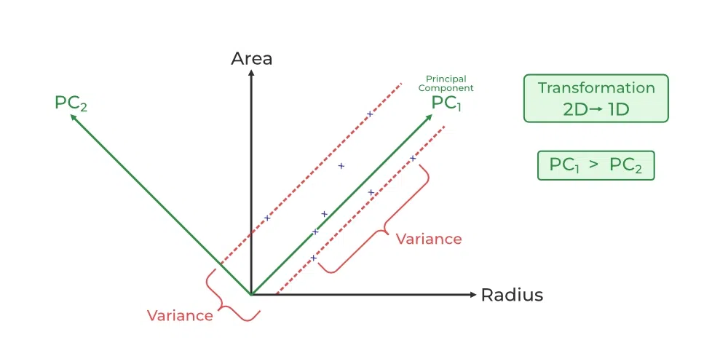
The dataset has two features: Radius and Area. PCA finds two new directions, PC₁ and PC₂.
- PC₁ captures the most variation (information).
- PC₂ captures the leftover variation and is perpendicular to PC₁.
Since the data spreads more along PC₁, we project the points onto it, reducing the data from 2D to 1D while keeping most of the important patterns.

4. Applications of PCA
- Data Preprocessing: Reduces the number of features, making machine learning algorithms more efficient.
- Data Visualization: Projects high-dimensional data onto 2D or 3D space for visualization.
- Noise Reduction: Eliminates less informative features, reducing noise in the data.
- Feature Extraction: Identifies underlying patterns in the data.

5. Advantages of PCA
- Reduces Dimensionality: Simplifies the dataset without losing significant information.
- Improves Efficiency: Decreases computational cost for machine learning algorithms.
- Enhances Visualization: Makes it easier to visualize high-dimensional data.

6. Disadvantages of PCA
- Linear Assumption: Assumes linear relationships between features; may not capture complex nonlinear patterns.
- Interpretability: Principal components are linear combinations of original features, making them hard to interpret.
- Sensitive to Scaling: Requires careful standardization of data.

Regression:
Regression in machine learning refers to a supervised learning technique where the goal is to predict a continuous numerical value based on one or more independent features. It finds relationships between variables so that predictions can be made. We have two types of variables present in regression:
- Dependent Variable (Target): The variable we are trying to predict e.g house price.
- Independent Variables (Features): The input variables that influence the prediction e.g locality, number of rooms.
Regression analysis problem works with if output variable is a real or continuous value such as “salary” or “weight”. Many different regression models can be used but the simplest model in them is linear regression.
Types of Regression
Regression can be classified into different types based on the number of predictor variables and the nature of the relationship between variables:
1. Simple Linear Regression
Linear regression is one of the simplest and most widely used statistical models. This assumes that there is a linear relationship between the independent and dependent variables. This means that the change in the dependent variable is proportional to the change in the independent variables. For example, predicting the price of a house based on its size.
2. Multiple Linear Regression
Multiple Linear Regression extends simple linear regression by using multiple independent variables to predict target variable. For example, predicting the price of a house based on multiple features such as size, location, number of rooms, etc.
3. Polynomial Regression
Polynomial Regression is used to model with non-linear relationships between the dependent variable and the independent variables. It adds polynomial terms to the linear regression model to capture more complex relationships. For example, when we want to predict a non-linear trend like population growth over time we use polynomial regression.
4. Ridge & Lasso Regression
Ridge and Lasso regression are regularized versions of linear regression that help avoid overfitting by penalizing large coefficients. When there’s a risk of overfitting due to too many features we use these types of regression algorithms.
5. Support Vector Regression (SVR)
SVR is a type of regression algorithm that is based on the Support Vector Machine algorithm. SVM is a type of algorithm that is used for classification tasks but it can also be used for regression tasks. SVR works by finding a hyperplane that minimizes the sum of the squared residuals between the predicted and actual values.
6. Decision Tree Regression
Decision Tree uses a tree-like structure to make decisions where each branch of tree represents a decision and leaves represent outcomes. For example, predicting customer behaviour based on features like age, income, etc there we use decision tree regression.
7. Random Forest Regression
Random Forest is an ensemble method that builds multiple decision trees and each tree is trained on a different subset of the training data. The final prediction is made by averaging the predictions of all of the trees. For example, customer churn or sales data using this.
Applications of Regression
- Predicting prices: Used to predict the price of a house based on its size, location and other features.
- Forecasting trends: Model to forecast the sales of a product based on historical sales data.
- Identifying risk factors: Used to identify risk factors for heart patient based on patient medical data.
- Making decisions: It could be used to recommend which stock to buy based on market data.
Advantages of Regression
- Easy to understand and interpret.
- Robust to outliers.
- Can handle both linear relationships easily.
Disadvantages of Regression
- Assumes linearity.
- Sensitive to situation where two or more independent variables are highly correlated with each other i.e multicollinearity.
- May not be suitable for highly complex relationships.

Difference between Classification and Regression
Feature | Classification | Regression
Output type | Target variables are discrete categories (e.g., spam or not spam) | Target variable is a continuous numerical value (e.g., price, temperature)
Goal | To predict which category a data point belongs to | To predict an exact numerical value based on input data
Example problems | Email spam detection, image recognition, customer sentiment analysis | House price prediction, stock market forecasting, sales prediction
Evaluation metrics | Precision, Recall, F1-Score | Mean Squared Error (MSE), R²-Score, Mean Absolute Percentage Error (MAPE), RMSE
Decision boundary | Clearly defined boundaries between different classes | No distinct boundaries, focuses on best fit line/curve
Common algorithms | Logistic Regression, Decision Trees, Support Vector Machines (SVM) | Linear Regression, Polynomial Regression, Decision Trees (regression objective)

Question
Fit a regression line y = a + bx for the following data:
x: 1,2,3,4,5
y: 2,4,5,4,5
Concepts used: Least Squares Regression, Regression Line, Mean, Sum of Squares, Slope and Intercept Calculation
The equation describes a straight-line relationship between input x and output y.
The regression line is written as:
y = a + bx
where:
- y → the predicted value (the output we want to estimate, like salary, weight, etc.).
- x → the input (independent variable, like years of experience, height, etc.).
- a → the intercept (the value of y when x = 0). It’s where the line cuts the y-axis.
- b → the slope (it tells us how much y changes when x increases by 1).

Step-by-Step Solution
Step 1: Find the means
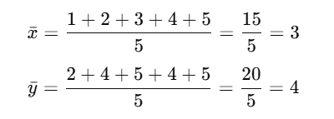
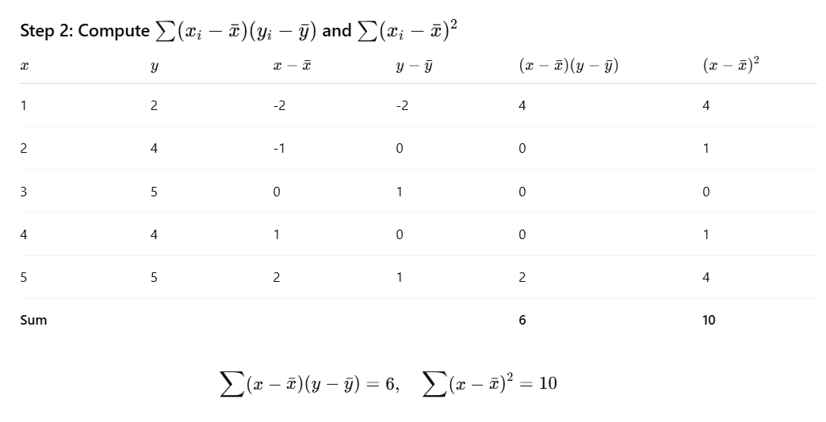

Step 3: Calculate slope (b)
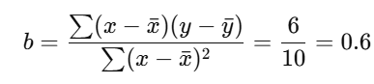
Step 4: Calculate intercept (a)
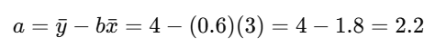
Final Answer
The regression line is:
Y = 2.2 + 0.6x

Linear Regression VS Logistic Regression:

Feature | Linear Regression | Logistic Regression
Problem Type | Used for regression, i.e., predicting continuous values. | Used for classification, especially binary outcomes.
Output | Provides a continuous value (e.g., temperature, price). | Provides probabilities for categories, often turned into class labels (via threshold).
Function/Form | Straight-line equation: y= a₀ + a₁x₁ + … + a_{n}x_{n}. | Uses sigmoid/logistic function to transform output: p=1/1+e^{-(…)}
Modelling Technique | Uses the Least Squares method to fit the best line. | Uses Maximum Likelihood Estimation to find best parameters.
Assumptions about Output | Assumes output is normally distributed. Residuals should be normal. | Assumes a binomial distribution, and links log-odds to inputs.
Graphical Shape | Produces a straight line (linear relationship). | Produces an S-shaped (sigmoid) curve.
Dependent Variable Type | Works when the dependent variable is numeric and continuous. | Works when the dependent variable is categorical (especially binary).

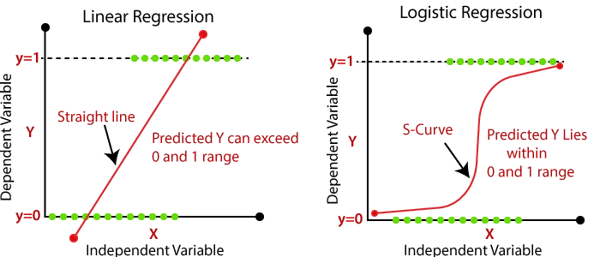

Bias in Machine Learning

1. What is Bias?
- Definition: Bias is the error introduced by approximating a real-world problem (complex) by a simplified model.
- In simpler words: bias occurs when the model makes assumptions about the data that may not be entirely correct, causing systematic errors.
- High bias → model is too simple → cannot capture the patterns → underfitting.

2. Types of Bias in Machine Learning
A. Based on Model Complexity
- High Bias
  - The model is too simple.
  - It assumes a strong structure on the data.
  - Example: Using linear regression on a highly nonlinear relationship.
  - Effect: Poor performance on both training and test data (underfitting).
- Low Bias
  - The model is flexible and complex.
  - Makes fewer assumptions about the data.
  - Example: Using a deep neural network on a small linear dataset might have very low bias but high variance.
  - Effect: Can fit data very well (risk of overfitting if not controlled).

B. Based on Source of Error
- Algorithmic Bias
  - Bias introduced because of the learning algorithm’s assumptions.
  - Example: Naive Bayes assumes independence among features.
- Sample Bias (Selection Bias)
  - Occurs when the training data is not representative of the real-world data.
  - Example: Training a face recognition model on mostly one ethnicity → poor generalization.
- Measurement Bias
  - When the data collected has systematic errors.
  - Example: Sensors that consistently under-report temperature.
- Prejudice / Societal Bias
  - Bias stemming from human decisions or social factors embedded in data.
  - Example: Historical hiring data reflecting gender discrimination.

C. Statistical Bias
- In statistics/machine learning, bias is part of the bias–variance tradeoff:
- High bias → high training error.
- Low bias → model can fit training data well but may have high variance

Statistical Decision Theory (SDT)
1. What is Statistical Decision Theory (SDT)?
- Statistical Decision Theory is a framework to make optimal decisions under uncertainty.
- It combines probabilities, data, and a loss function to choose the best action.
- In regression, the “decision” is the predicted value, and the “uncertainty” is the true value we don’t know.
- The main goal is to minimize expected error (risk) in predictions.
- Example: Predicting house prices using data on size and location while accounting for random market fluctuations.

2. Key Components of SDT in Regression
- Decision (Prediction):
  - In regression, the decision is the predicted value $\hat{y}$ for a given input x.
  - Example: Predicting house prices based on features like size, location, etc.
- State of Nature (True Value):
  - The actual outcome y which is uncertain.
  - Example: The real price of a house may vary even for similar features due to market fluctuations.
- Loss Function:
  - Measures how bad a decision is when the prediction differs from the true value.
  - Common loss functions in regression:
    - Squared Error Loss:
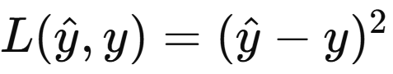
      - Punishes large deviations more.
    - Absolute Error Loss:
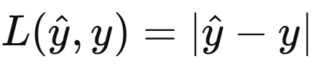
      - Less sensitive to outliers.
- Risk (Expected Loss):
  - The expected loss over all possible outcomes.
  - Formula:
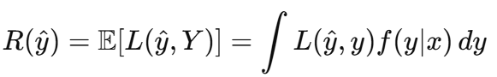
  - Where f(y|x) is the probability of y given input x.

3. Regression from SDT Perspective
- In regression, the goal is to choose a prediction rule $\hat{y}\left(x\right)$ that minimizes expected loss.
- Example:
  - Suppose we want to predict the weight of a person given their height.
  - The true weight is uncertain, and the relationship has some randomness.
  - If we use squared error loss, the optimal prediction is the conditional mean:
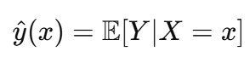
  - If we use absolute error loss, the optimal prediction is the conditional median.

4. Example of SDT in Regression
Scenario: Predicting exam scores based on study hours.
- Suppose the true relationship is: Y=10+5X+ϵ, where ϵ is random noise.
- Decision: Predict $\hat{y}$ for a student who studied X=4 hours.
- Using squared error loss:
  - Optimal prediction is the expected value:
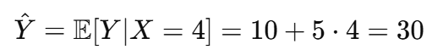
- Using absolute error loss:
  - Optimal prediction is the median of the distribution of Y for X=4.

5. Steps to Apply SDT in Regression
- Define the problem: Identify inputs X and output Y.
- Choose a loss function: Decide how you want to penalize prediction errors.
- Model the conditional distribution: Estimate f(y∣x)f(y|x) using data.
- Compute the optimal prediction: Use expected loss minimization.
- Make predictions: Use the optimal decision rule for new data.

6. Why SDT is Useful in Regression
- It provides a principled way to make predictions under uncertainty.
- Different loss functions allow flexibility depending on the application.
- It explicitly considers uncertainty instead of just fitting a line.
- Example: In finance, predicting stock prices using SDT allows accounting for the cost of overestimating vs. underestimating.

Multivariate Regression:
Multivariate regression is an extension of simple linear regression. Instead of using only one independent variable, it uses two or more independent variables to predict the value of a single dependent variable. This method shows how each independent variable contributes to changes in the dependent variable, while keeping the effect of others constant.
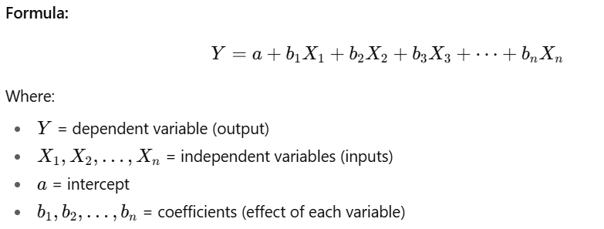
Example:
Predicting house price (Y) using size (X1), location (X2), and number of bedrooms (X3).

